Setup MongoDB

* First Logon to mongodb.
* Create a new Project, name it to fit with the app/website/other you are using it with.  
    
  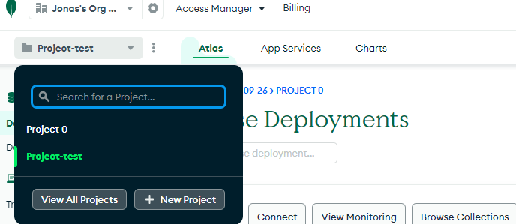
* Press build Database and select the free shared version skip everything in this setup and just press Create Cluster.
* Now to authenticate your connection just enter a username  
  and password and press Create User, this is just so you can edit the db settings.
* In Where would you like to connect from just choose  
  My Local Enviroment and Enter the ip as shown below.  
  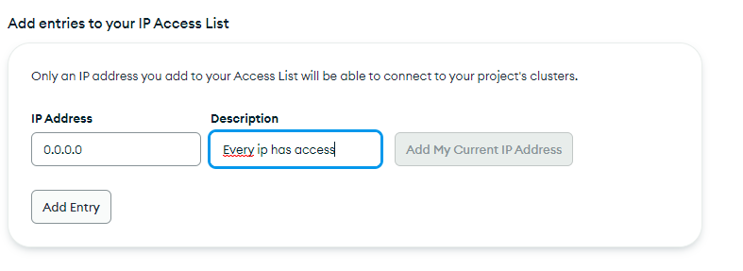

Press Add Entry  
Press Finish and Close

* Now you have setup your DB Cluster
* In the newly created cluster press browse collections and press  
  add own data type in database in the upper input field  
  and in the collection name type users  
  click create.
* In the new database hover on the database dropdown and press  
    
  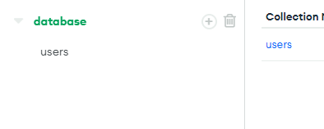  
    
  the + icon and insert a new collection for   
  classes, teams, stepLogs  
    
  - In the top of the screen press the App Services button

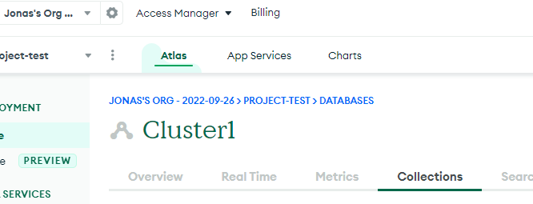

* Press build your own App and Next.
* In the new screen input the settings as such  
    
  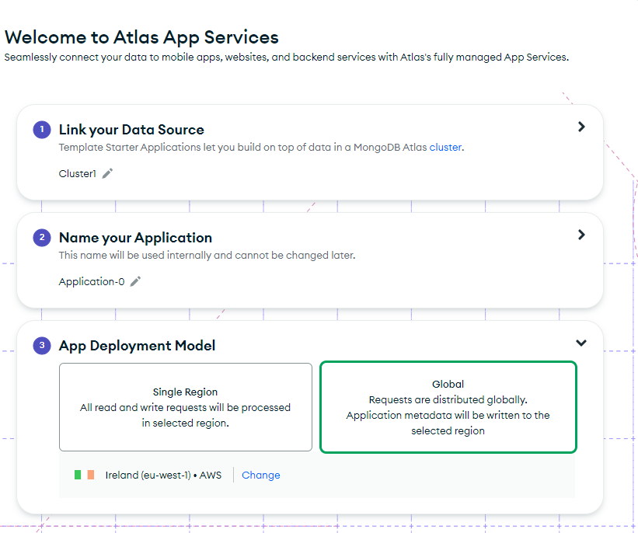
* Now go under Data Access and press Authentication
* Enable email/password and anonymousLogin authentication
* Go under custom user data and set settings as such  
    
  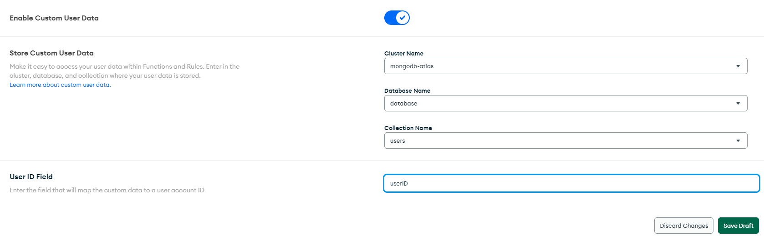
* Under the email/password authentication setup like this  
    
  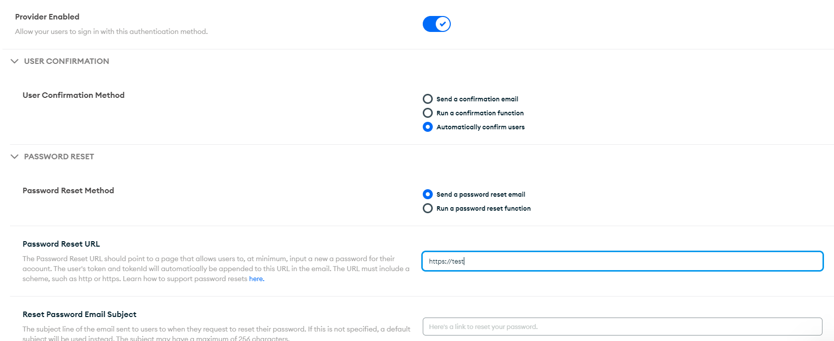
* Insert one document into each collection as such _id is automatically made

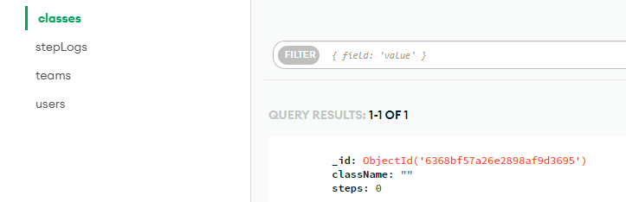

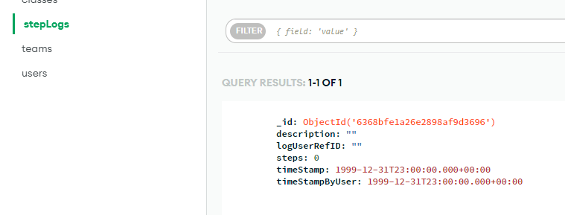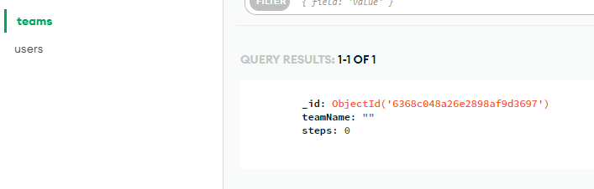

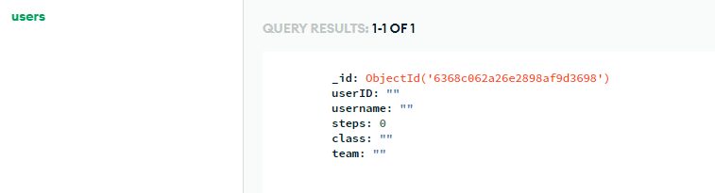

* Now go under app services again and select Schema  
  go through all collections and press generate schema from document
* Go into users and change team to be nullable like this  
    
  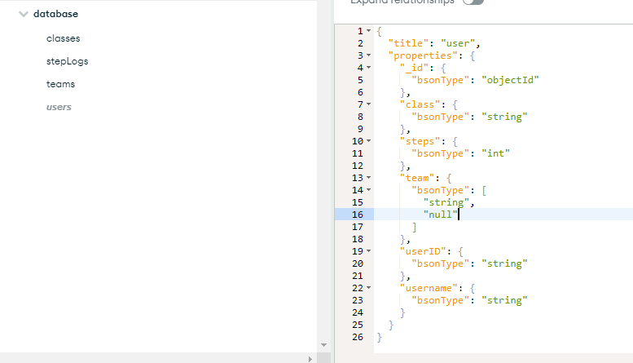
* Go under rules and select each collection under set up roles for this collection set to readAndWriteAll and add do this for each collection  
    
  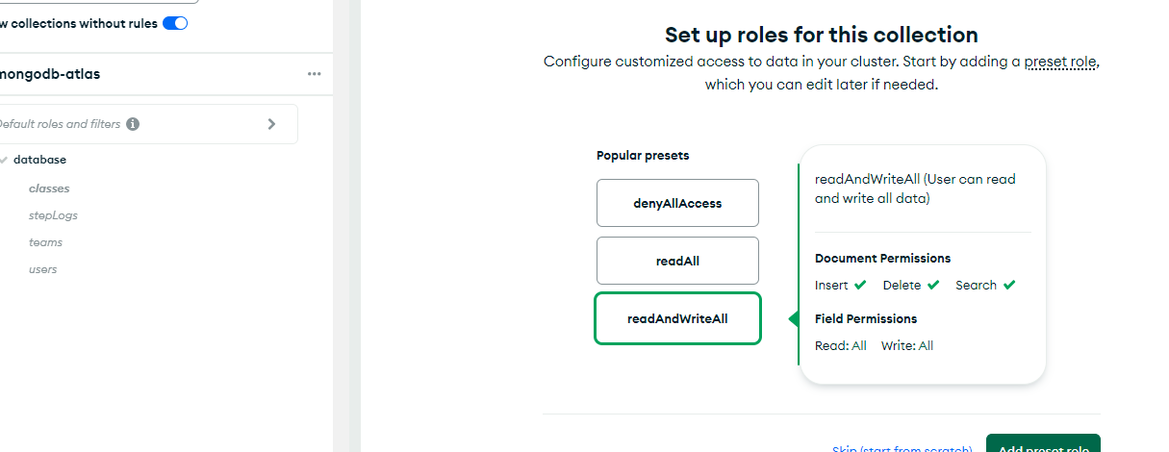
* On top of the site press review draft & deploy
* On top of screen press Application-0 and copy the App ID  
    
  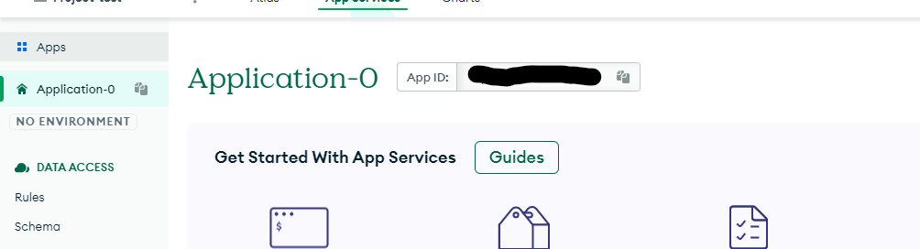  
    
  Keep this private
* Now go into the Taelskridt application go into the App.vue file located under src find the line as shown below and input the new  
  id in the id strings  
    
  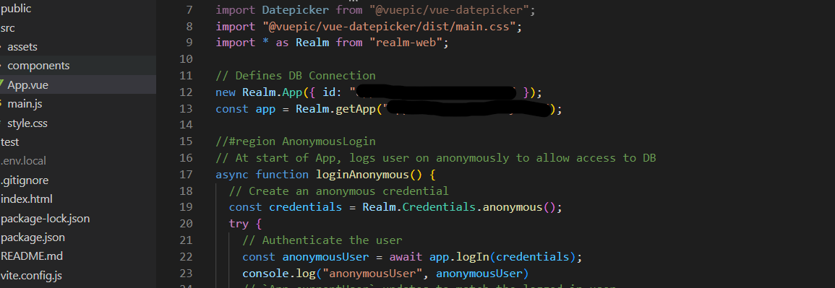  
    
  Now the app has the id of your db deployment
* Go into the Device Sync select flexible and under select a cluster to sync select your cluster
* Under Define permissions set ReadAndWriteAll  
  Save changes and deploy
* Now delete the data in your collections  
  and try to create a new user on the website if it works you should  
  be able to logon